CookingWare Final Design Report

April 21, 2026

Justin Zhan

Chase Keller Advised by Hrishikesh Vinayak

Table of Contents
Table of Contents 2
Project Description 3
User Interface Specification 4
Test Plan and Results 10
User Manual 12
Assessments 12
Summary of Hours and Justification 12
Summary of Expenses 13
Appendix 13

Project Description

This project is a website that will host a game made in React, where the player must cook food under a certain amount of time. Focus will be on the design of the frontend and the four games that will be included at the time of the expo.​ All assets used on the website will be created by the team, or they will be free assets found online with credit given to the creators on the website.

User Interface Specification
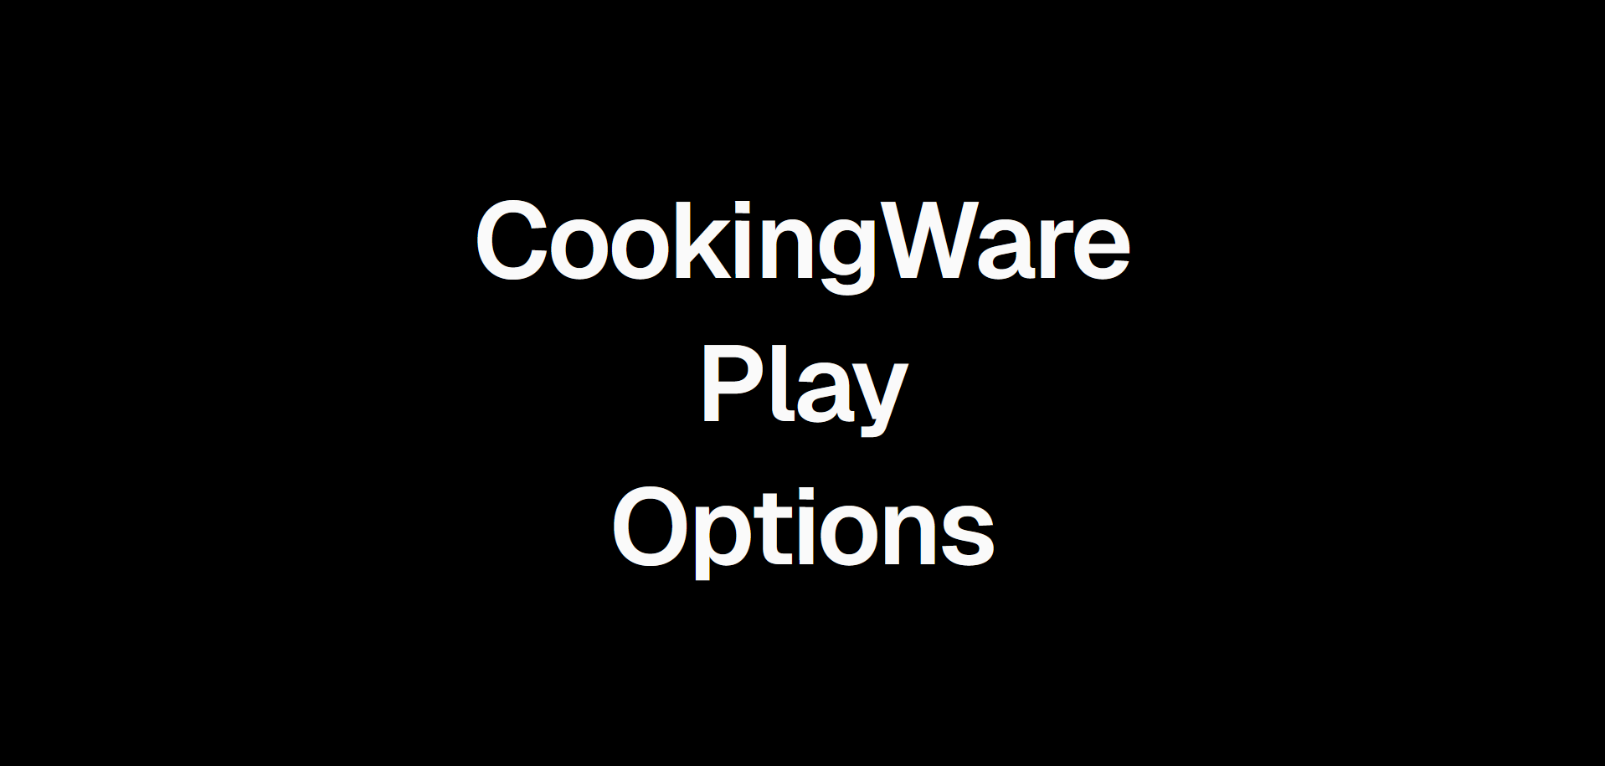
This is the title screen. Clicking options takes the player to the options screen. Clicking play will navigate the player to a new page which will load minigames until they run out of lives.

This is the options page. Clicking back will take the player back to the main menu. Clicking credits will take the player to the credits page.

This is the credits page. Clicking back will take the player back to the options page.
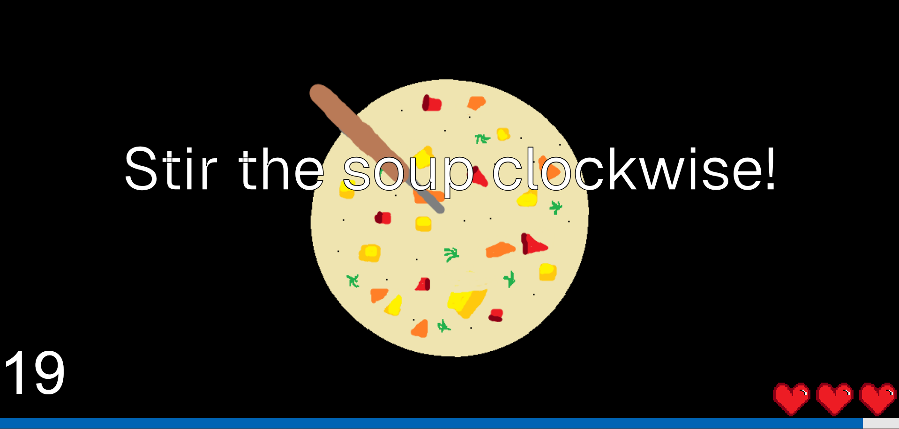
This game requires the user to move the mouse from the top left quadrant of the screen to the top right, then to the bottom right and so on, until they have stirred the soup enough.

This game requires the player to remember a list of groceries that they must then select from a line up. This screen will lead into the grocery list screen.
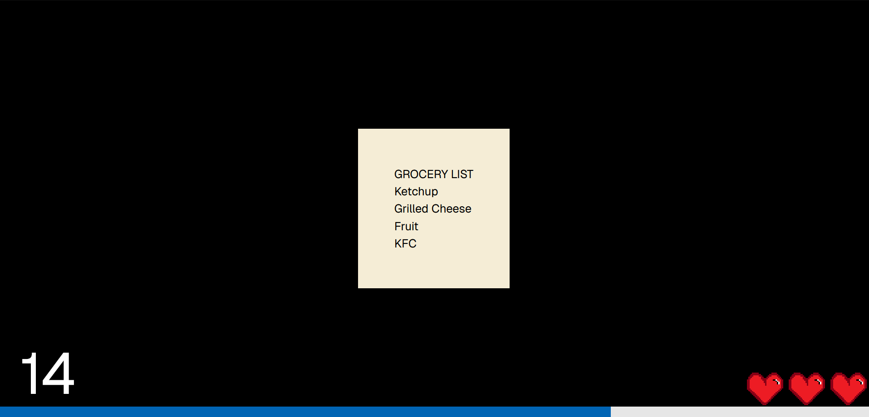
This is an example of a grocery list that the user must remember.
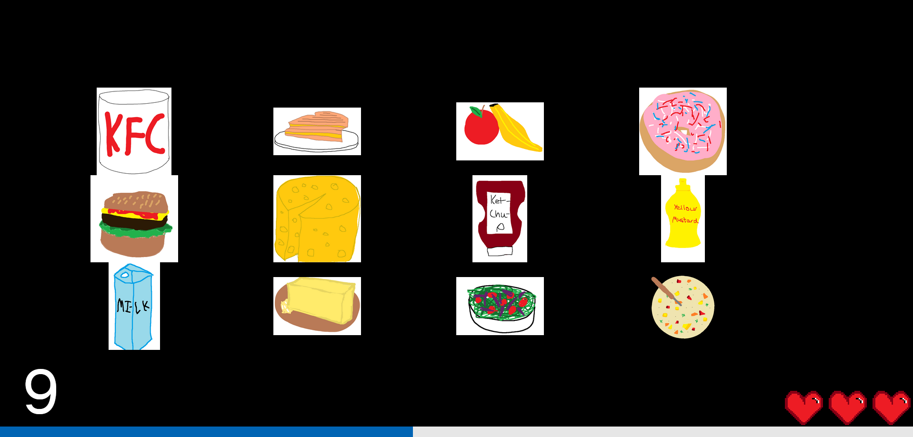
This is the lineup of groceries that the user must remember.
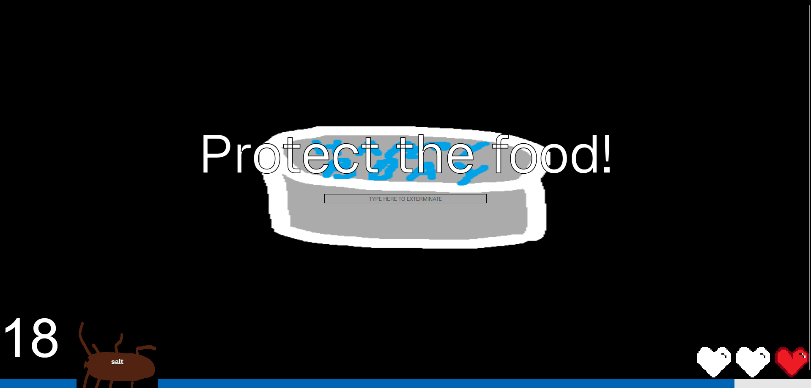
This game requires the user to type the words on the backs of the cockroaches into the textbox on the cake to exterminate them. If the cockroaches reach the center of the screen, the player loses.

This game requires the user to click on all the popcorn kernels that appear on the screen.

This screen is shown if any game is lost, either by clicking something wrong or running out of time.

This is the gameover screen, which is shown after the game lost page, if the player is out of lives.

This screen is shown after the player successfully completes a minigame.

Test Plan and Results

This test plan will include a manual run of each of the games, as well as a test of the audio option.
Test Case | Outcome
Navigating to cooking-ware.com displays the play game screen | The play game screen is shown
Clicking options shows options | The options screen is shown
Clicking credits shows credits | The credits screen is shown
Changing the audio level changes how loud sounds are | Sounds change with the audio setting
If the player loses the game, the game lost screen is shown and a life is deducted | The game lost screen is shown, and a life is deducted
If the player runs out of lives, the game over screen is shown, and they are navigated to the home page | The game over screen is shown, before the player is navigated to the home screen
Stirring the soup enough results in the player winning | The player wins the game
Not stirring the soup enough results in the game lost screen | The game lost screen is shown
Clicking all the popcorn kernels results in the player winning | The player wins the game

Not clicking all the popcorn kernels results in the player losing | The player loses
Clicking the wrong grocery item or running out of time results in the player losing | The player loses
Clicking the grocery items in the sequence shown in the list results in the player winning | The player wins
Typing in the word on the cockroach’s back removes the cockroach | The cockroach was removed
Typing in the word on the last cockroach’s back when the timer runs out results in the player winning | The player wins
Allowing a cockroach to touch the food in the center results in the player losing | The player loses

User Manual

Navigate to “cooking-ware.com”
Click play game and follow on-screen instructions to play the minigames
Click options to change the volume

Assessments

The self-assessment from the fall is available on the GitHub repository.
Overall, I’m happy that I was able to make some working games; however, I did not anticipate the amount of work that goes into creating a gaming experience. For example, I think that having animations would greatly help my project, but that wasn’t accounted for in planning and allocating my time and would have required a lot of learning to be done, which I simply did not have time to do this semester. I would also have liked to have more art for the backgrounds, but that would require redrawing and exporting all the current assets, as the images all have opaque backgrounds. Moving forward with the project, the three major focuses would be creating a difficulty system where the games get faster or require more actions, creating a leaderboard system, and creating more stylized artwork, animations, and sound effects.

Summary of Hours and Justification

15 hours were spent designing games, artwork, and audio.
25 hours were spent programming the games and setting up the website.
5 hours were spent on documentation and creating presentations.

Summary of Expenses

The only expense of this project was the domain, which cost $11. All other materials were either free to use or were created by the team.

Appendix

The GitHub repository, including all other documentation and code can be found at https://github.com/kellec8/ck-senior-design.

